**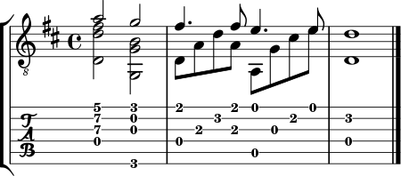  
 Tab to MusicXML**

# User Manual

**Version 2.0**

**03/17/2021   
Group 1: Lian Attily, Alborz Gharabaghi, Robert Mealey, Derui Liu, Isaiah Linares**

**Table of Contents**

User Manual 1

1. Introduction 1

2. Overview 1

2.1 Conventions 2

3. Getting Started 3

3.1 System Requirements 3

3.2 Installing the System 4

3.3 Exiting the System 4

4 Using the System 5

4.1 Uploading a tab as a text file (*.txt) 5

4.2 Pasting tablature into the textarea 6

4.3 Exporting a MusicXML file 7

5. Error Handling 9

6. Troubleshooting 10

## Introduction

The purpose of this document is to serve as a user manual and provide the users of Tab to MusicXML with a detailed, step-by-step guide on how to install and use the software. The intended audience for this document includes the testers for our application, as well as our customer. This document should cover all of the relevant use cases for the most up to date version of our application, further version changes will be reflected in this document as well.

## Overview

The purpose of the Tab to MusicXML software is to provide the user with a simple and easy-to-use tool to convert ASCII tablature to MusicXML. It is a standalone Java based desktop application that can be run offline. The user will interact with our software through a graphical user interface that will be simple and easy to use. The application will allow the user to import a tab of their choosing, fill in any extra options, and export it into a music XML file.

### Conventions

1. *As for right now (March 17th, 2021) drum and bass tabs are not fully supported yet. They are still in the parsing stage, and so the output will likely be incorrect. Only guitar tabs have been implemented correctly.*
2. The figure below is an example of a properly formatted row of guitar tablature that can be processed by the software:
3. 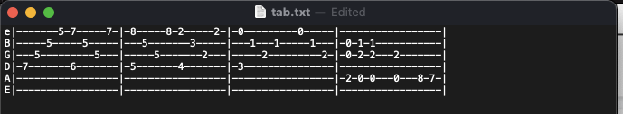

For guitar tabs, the user must follow the following conventions:

* General Formatting:
  + Comments and Metadata (Title, Composer, etc.) is allowed, but cannot be inline with the tablature
  + Spacing between rows of tablature does not have to be consistent, and can include comments or lyrics
* Tab Formatting:
  + Each row of the tablature (see above) may start with the string tuning information (not required)
  + Measures are separated from the tuning information and each other by lines |
  + Each row must contain at least one measure
  + Measures must have a consistent length
* Guitar/Bass Content restrictions:
  + String tuning must be a single character, case does not matter.
  + Each measure can only contain dashes - and numbers 0-9
  + Each measure must contain at least one valid character
  + No trailing white spaces at the end of each line
* **Copying and pasting a tab from an online website may format the tab incorrectly. As of right now, the system cannot support incorrectly formatted tabs
  + - For example: On Mac Version 11.2.3, copying a tab from asciitabs.com on Safari will result in an incorrect tab in the text area (only case found so far).

1. We are still in the process of parsing through tablature of other forms and instruments. Any other input ***will produce an incorrect MusicXML file* (check the console for stack trace, or GUI message pop-ups)**.
2. ***As of right now, the default values (Guitar, (¾ and 4/4), C Major) are the only correctly implemented attributes.***

## 3. Getting Started

### System Requirements

Before installing the software, please ensure that you have Java-15 installed on your computer. If not, please follow this link to download it:

<https://www.oracle.com/ca-en/java/technologies/javase-downloads.html>.

To check if you have it, go to **File → Properties → Java Compiler → Compiler Compliance Level → 15** (Check screenshot below for reference).

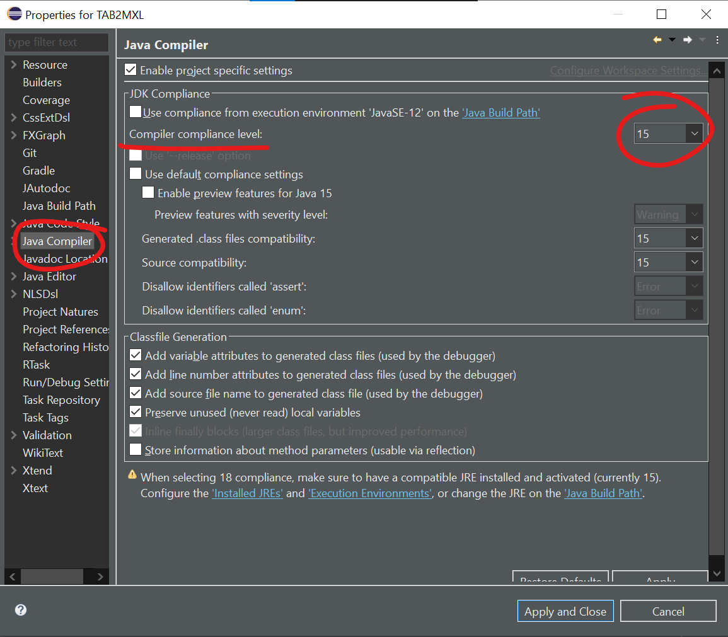

### Installing the System

To install and run the software:

1. Clone the repository from Github: <https://github.com/alborzdev/2311-Project>
2. Make sure that you are in the **master branch**
3. If you do not see the “Gradle Tasks” window in Eclipse (see image below). Go to **Window → Show View → Other → Gradle Tasks**.
4. Refresh the gradle tasks.



1. Click on the TAB2MXL folder → build → assemble (double click).
2. Click on the TAB2MXL folder → application → run (double click).

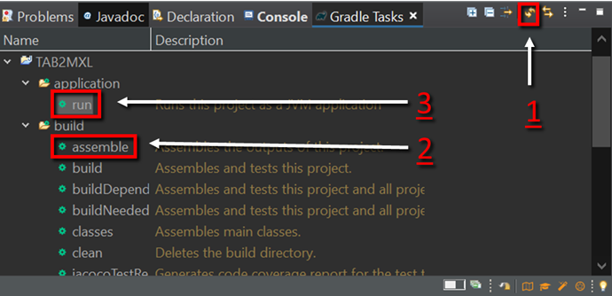

*Please note that clicking “build” will run the Junit and TestFX unit tests.*

### Exiting the System

You may exit the system simply by:

* Clicking the “x” button at the top right of the screen,
* In the menu bar: File→ Exit

## Using the System

When you run the software *(See* *section 3.2* *on how to install and run the software)*, you will see the following main screen:

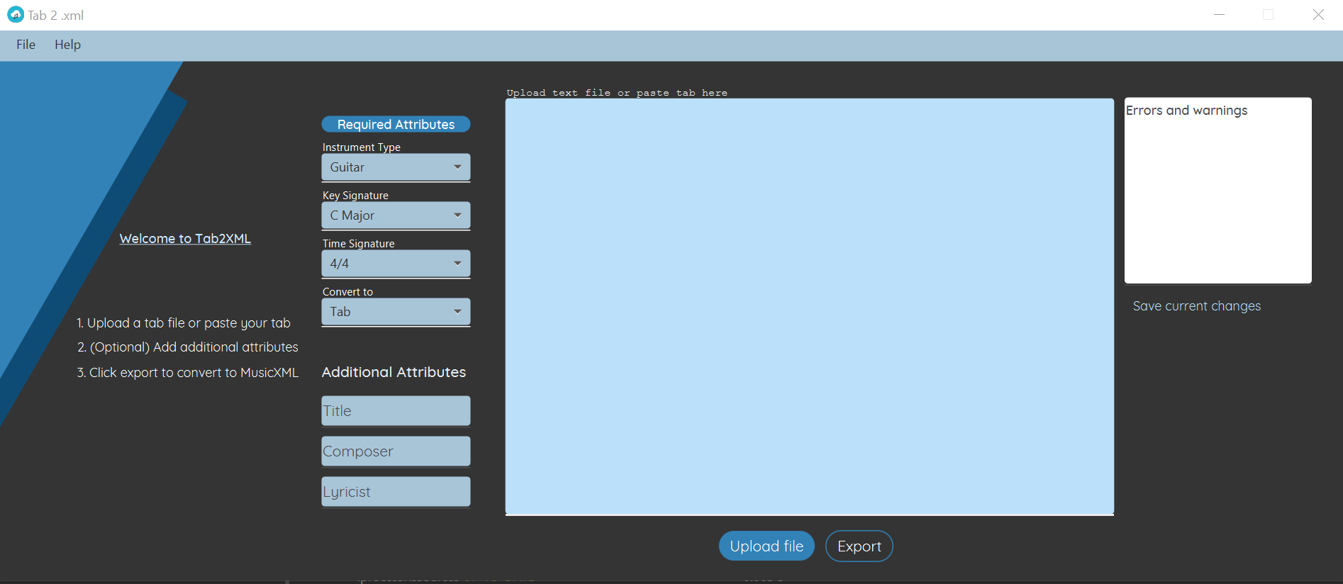

*Figure: Software Main Window*

The following subsections provide detailed, step-by-step instructions on how to use the various functions or features of the Tab to MusicXML software.

### Uploading a tab as a text file (*.txt)

In order to export a MusicXML file, the user needs to import an ASCII tab of their choosing into the program. One way they might choose to do this is through uploading a text file containing the tab. First, the user must click on the **Upload File button**. Then, a window will pop up, prompting the user to specify the location of their file and select it. The user should then see the **tab from the file in the text area**, where they can edit it if they wish.

Click on the “Upload file” button to import a tab.

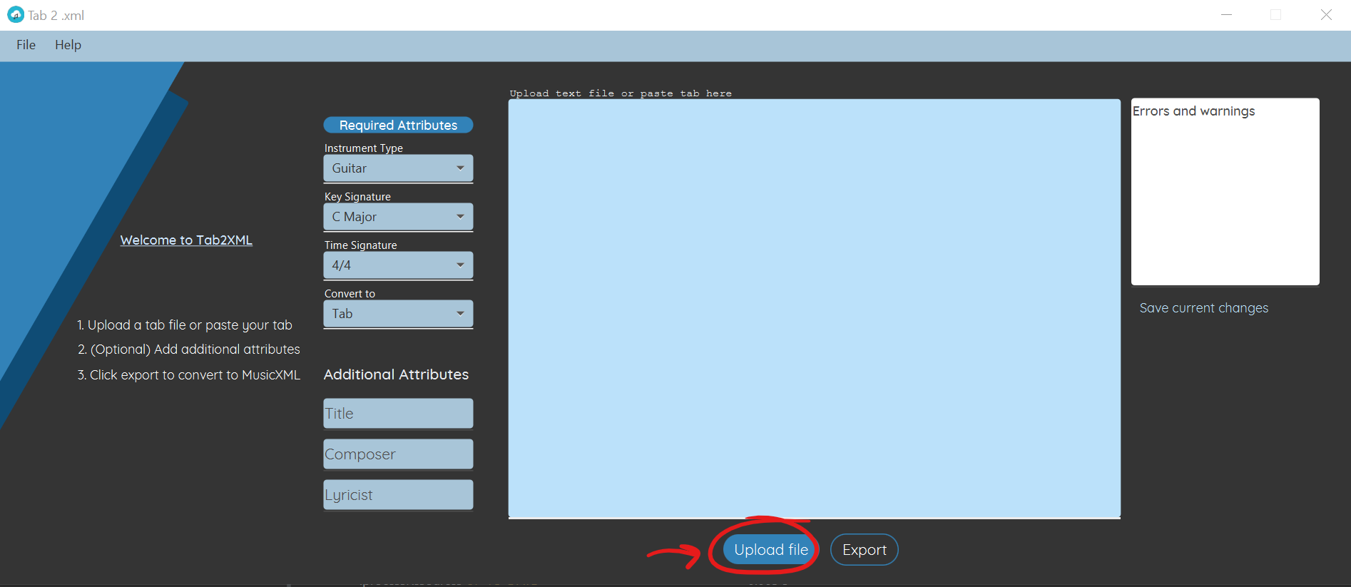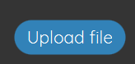

 Select a .TXT file that contains supported tablature.

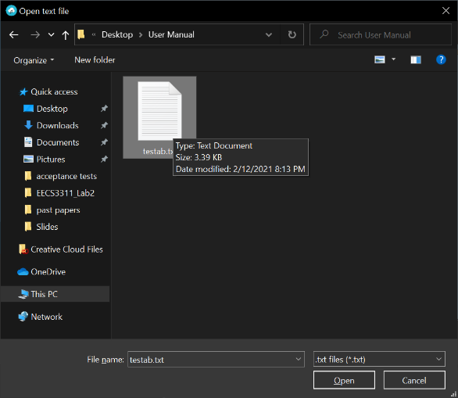 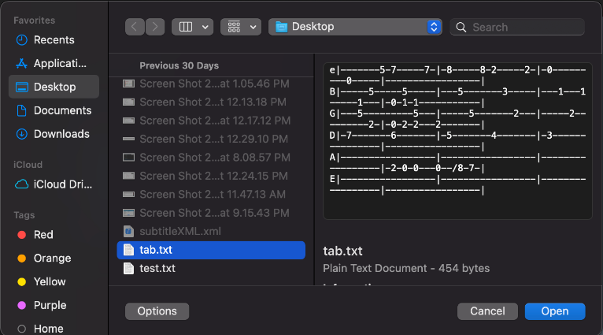

***(On Windows) (On Mac)***

You can now view your imported tab in the text area.

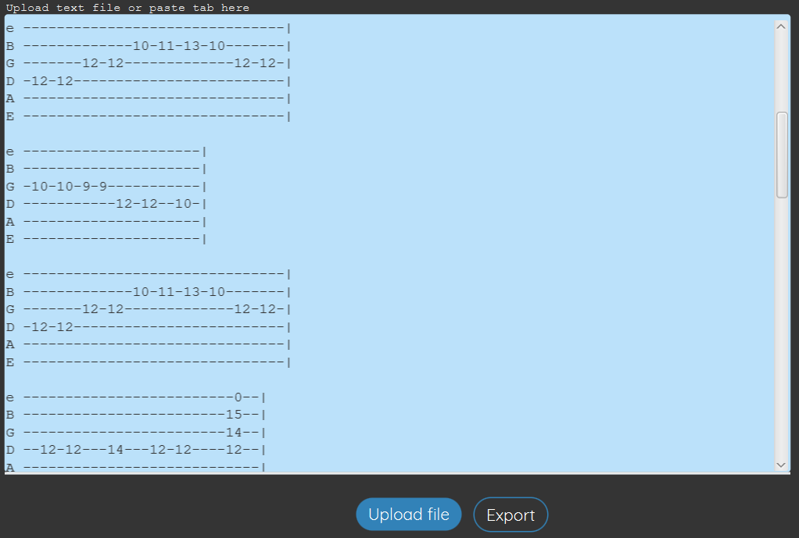

### Pasting tablature into the textarea

Another way for the user to input their tab is to paste is directly into the text area. They can click on the big box and paste, type, and/or edit their tab until they are satisfied.

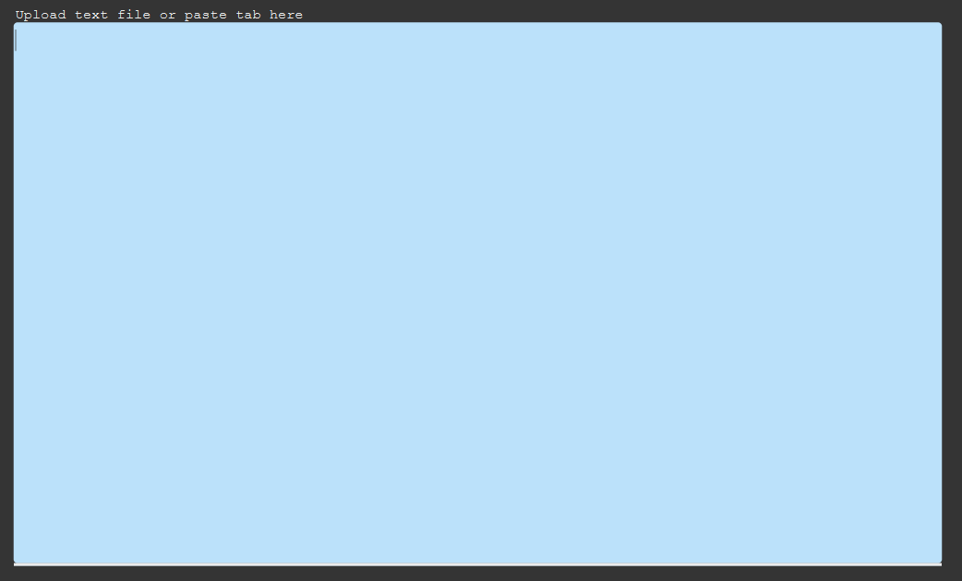

### Exporting a MusicXML file

Once the user is satisfied with their tab, they can convert the tab into a MusicXML by clicking the “Export” button. A window will then pop up, prompting the user to specify the name of the .xml file and save it in their desired location on their computer.

Click on the “Export” button.

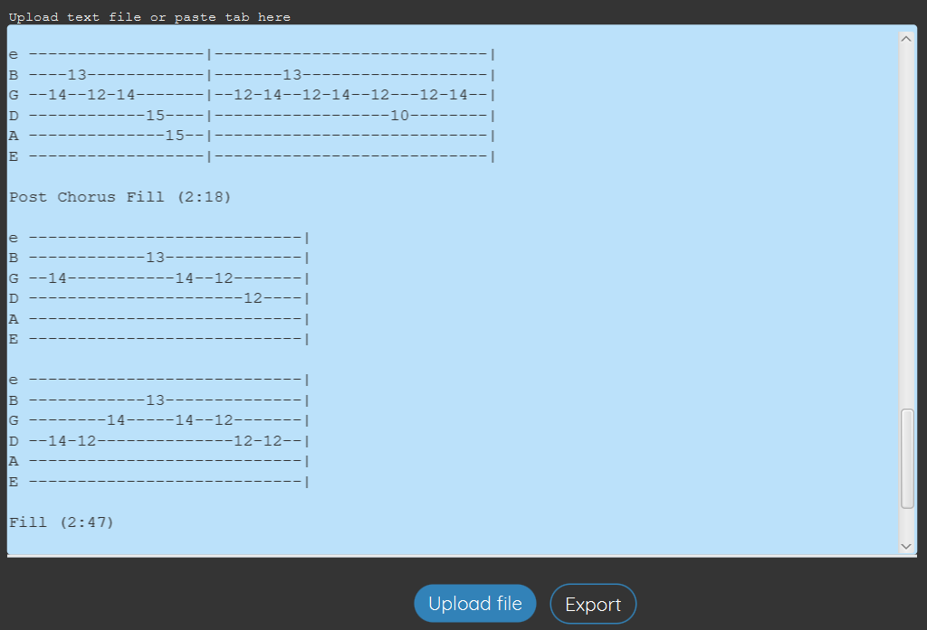

Enter a filename and click on “save” to finish exporting.

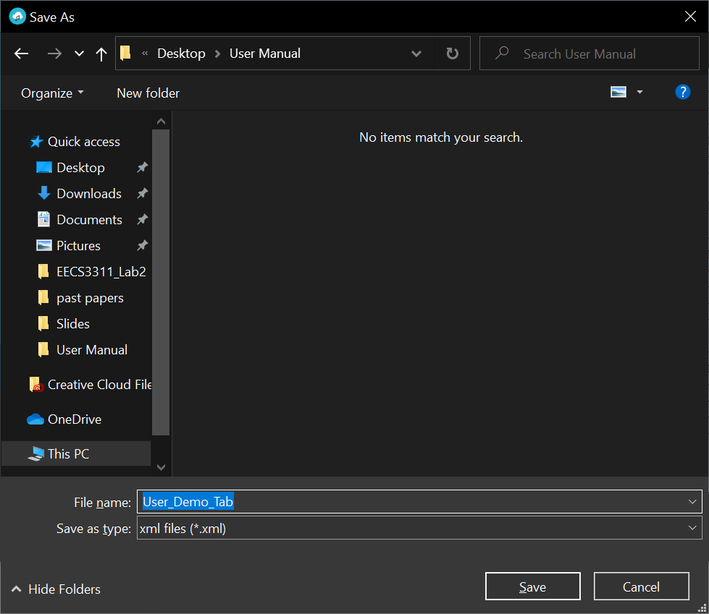 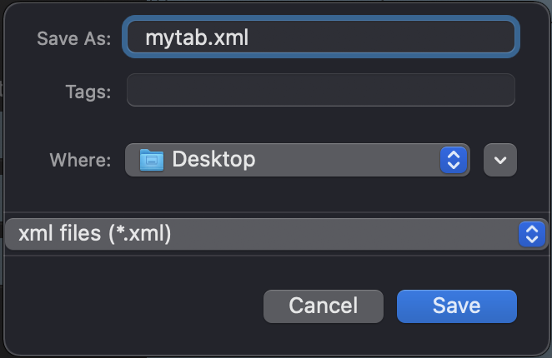

***(On Windows) (On Mac)***

Here is a sample output of a MusicXML file that was exported and then opened with MuseScore:

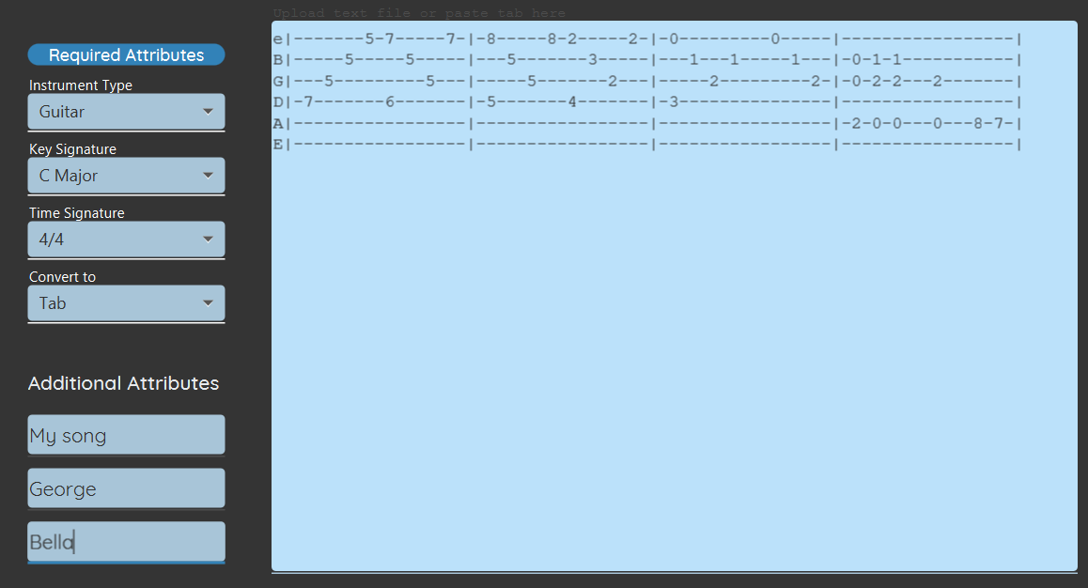

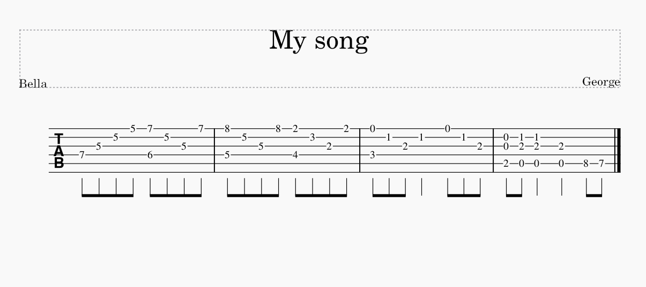

* 1. **Save current settings**

To save the settings of the current file (in order to load them later on), the “Save current changes”.

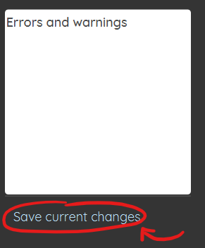

* 1. **Load recent file**

To load the most recently saved file and its settings, click on **File → Open Recent**

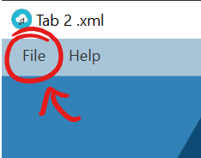

This will load the most recent save state of the application.

* 1. **Adding additional attributes into text fields**

This feature allows the user to add additional attributes to the MusicXML file by clicking on the text field and typing in the attributes accordingly.

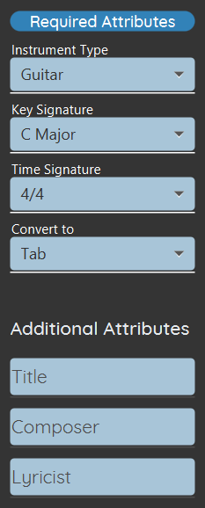 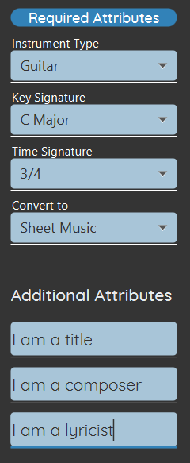

**Default values:**

* **Instrument Type:** Guitar
* **Key Signature:** C Major
* **Time Signature:** 4/4
* **Convert to:** Tab

### 5. Error Handling

**5.1 Overwriting text area Warning**

If you are uploading a new file or reloading recently saved files to a non-empty textarea, the system will check if you would like to clear the current text and replace it or simply append the file to the current text area. It also allows the user to cancel uploading the file altogether

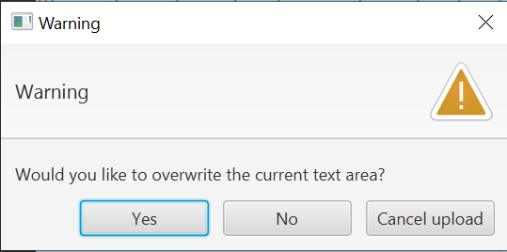

**6. Troubleshooting**

*If you run into any issues while using or trying to run the software, please join our Troubleshooting Discord chat:* [*https://discord.gg/Nves88Mw*](https://discord.gg/Nves88Mw)

*Or contact:*

* **Lian Attily:** [**lian0208@my.yorku.ca**](mailto:lian0208@my.yorku.ca) **|| discord: tears#3197**
* **Aidan (Robert Mealey):** [**mealey@my.yorku.ca**](mailto:mealey@my.yorku.ca) **|| discord: Inept#4779**